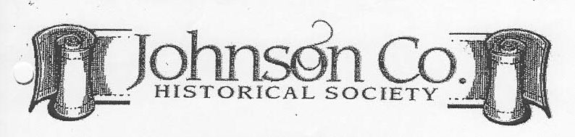

Heritage Center Museum
131-133 W. Main Street
P. O. Box 2107
Clarksville, Arkansas 72830
479-754-3334 JCHS1833@gmail.com johnsoncountyarkansashistoricalsociety.com

MEMBERSHIP/DONATION FORM
Name: ______________________________________________________________
Mailing Address: _____________________________________________________
City/State/Zip:________________________________________________________
Home Phone: ___________________ Cell Phone: __________________________
E-Mail:______________________________________________________________
Receive Journal via PDF_____ (requires email address)

Date: ___________
_____Dues: for year 20__ ($20/yr) New__ Renewal __Lifetime ___($300) $ ________
_____Donation to help with Heritage Center yearly costs (Tax Deductible) $_________
_____Donation to help with Heritage Center building fund (Tax Deductible) $_________
_____Memorial (Tax Deductible) ____ Honorarium (Tax Deductible) _____ $_________
Honoree: ____________________________________________________________
Acknowledgment to: __________________________________________________
Address: ____________________________________________________________
TOTAL AMOUNT DUE $_________

__________________________
Volunteer Signature
*******************************************************************************************************************************
Yearly memberships run from January 1 of each year to December 31 of that year. While membership includes husband and wife, only one copy of The Journal will be mailed twice each year as part of the membership. However, extra copies are available at the Heritage Center for $6.50 each. If the Society has not been notified of address changes, the member will be responsible for the postage to remail returned Journals.

Please remember that the Heritage Center is financed by donations and memorials and operated completely by volunteers. JCHS member volunteers and financial support is absolutely vital for the Center to remain open. Both the act of volunteering and financial donations are greatly appreciated by the Board and present volunteers.

